PRESS RELEASE

**PHILADANCO! comes to Cincinnati: January 21-22, 2022**

**FOR IMMEDIATE RELEASE**

The Philadelphia Dance Company, PHILADANCO! — a world-renowned company known for preserving African American traditions — is presented by Mutual Dance Theatre and The Jefferson James Contemporary Dance Theater Series

 December 15, 2021

 CINCINNATI, OHIO — In continuation of Mutual Dance Theatre’s 50th season (adopting its numeration from merged organization Contemporary Dance Theater), the organization also formerly known as MamLuft&Co. Dance, presents a world-renowned dance company, The Philadelphia Dance Company on January 21 and 22, 2022 at the Aronoff Center for the Arts.

PHILADANCO! has been described as **“an imaginative, gorgeous and thrilling dance company who showcase some of the best African American traditions in dance that really enhance their heritage”** (London, UK). The Company has performed on major stages including Jacob’s Pillow, The Joyce, Heinz Poll, and many others.

Founded 51 years ago by Joan Myers Brown in order to give Black dancers opportunities denied elsewhere, the Company and its school flourished to become **“a brilliant mix of of miracle skill, energy, and artistry.”** Its performers exhibit **“virtuoso physicality”** in **“fascinating and thrilling”** performances.

Across the nation and around the world, PHILADANCO! is celebrated for its innovation, creativity, and preservation of predominantly African American traditions in dance.

Artistic Director Kim Y. Bears-Bailey and Company will bring to Cincinnati a variety of choreographic works*.

**“Conglomerate” by Anthony Burrell, choreographer for Mariah Carey and Beyonce, formerly of Alvin Ailey American Dance Theater**

Choreographer Anthony Burrell boasts a résumé chock-full of big names in both dance theatre and the entertainment industry. From choreographing for Pepsi, DKNY, Beyonce, Mariah Carey, GLEE, The Oprah Winfrey Show, and many others, to having performed with stage companies PHILADANCO!, Koresh Dance Company, and Alvin Ailey, Burrell is teeming with talent and expertise. About “Conglomerate,” Burrell writes: “This work pays homage to the rich history of Black Dance in Philadelphia that inspired my journey as a Dancer, Choreographer, and Creative Director.”

**“With(in)verse” by Tommie-Waheed Evans, 2021 Guggenheim Fellow**

Tommie-Waheed Evans is a 2021 recipient of the coveted Guggenheim Fellowship. Evans (born and raised in Los Angeles) is a queer, Black, dance-maker whose work has been influenced by the racial divide, gang warfare, and earthquakes of his hometown. He explores Blackness, spirituality, queerness, and liberation through his work. “With(in)verse”, he says, “does not seek to be gospel as celebration, nor as evangelism. This is gospel as desperation. The work intertwines the ideas of spirituality and sorrow by focusing on the often strong presence of these ideas when hitting rock bottom. Pastor T. L. Barrett’s song ‘Father Stretch My Hands’ becomes the embodiment of deliverance.”

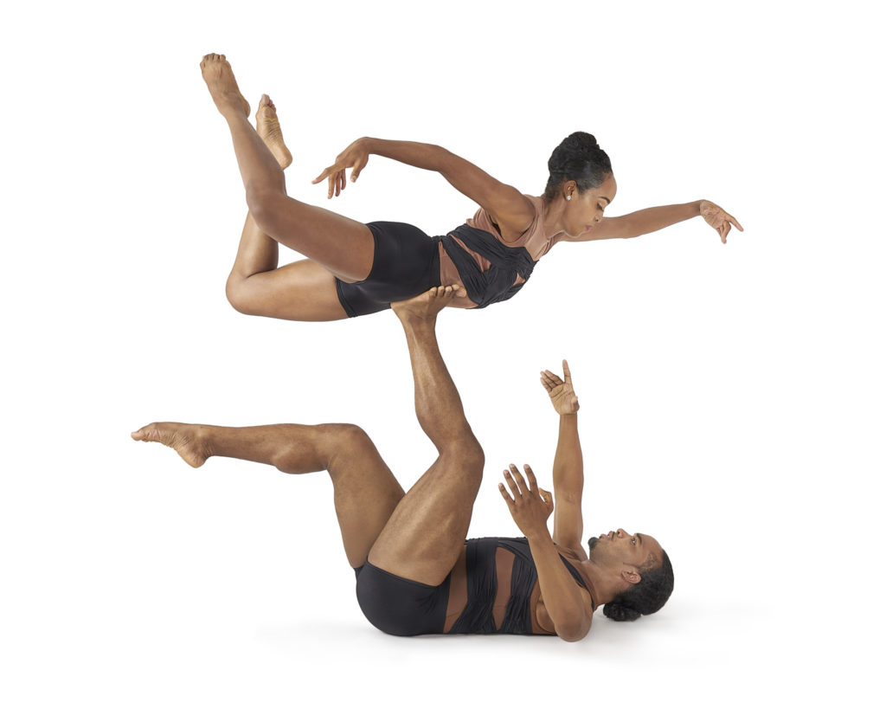

**“This Place” by Ray Mercer, of Alvin Ailey American Dance Theater and The Lion King**

Ray Mercer, of Alvin Ailey American Dance Theater fame, has also appeared in Broadway’s The Lion King. The native of Omaha, Nebraska won the Jeffrey  Ballet Choreographers of Color Award in 2012 and performed with Deeply Rooted Dance Theater, Boston Ballet (as a guest artist), and many others. His choreography — which can be seen on Dayton Contemporary Dance Company, New Jersey Ballet, Dallas Black Dance Theatre, and many others — has been recognized in The New York Times and the Chicago Sun Times. Mercer’s work on PHILADANCO!, “This Place” is “motivated by the idea and feeling of community,” he writes. “It is a collage of movements that addresses how a group that shares a common interest interacts socially, humanistically, and intimately. This is a technically-based, high-energy, physical work that explores many aspects of community in five very different sections, coming together in one collage of work.”

**“Between the Lines” by Francisco Gella, Artistic Director of Zeitgeist Dance Theatre**

Filipino choreographer Francisco Gella is a former dancer of PHILADANCO! who also performed with Repertory Dance Theater and Ballet Pacifica. He’s worked with Spectrum Dance Theater, California Ballet, and many others, including the closing ceremonies in the 1998 Nagano Winter Olympics. He has received numerous choreography awards, including at the Youth America Grand Prix International Ballet Competition and the National Regional Dance America Conference in 2007. Gella describes **“Between the Lines”** as “a work that was created and inspired by the architectural drawings of Frank Lloyd Wright, who was himself inspired by Beethoven’s lush compositions. Wright often stated that whenever he listened to Beethoven’s music, he saw movement and design. The dance illustrates a certain architectural flare with more than a hint of romanticism while drawing influences from choreographic legend Gene Hill Sagan and the classical idiom.”

*(*Works are subject to change.)*

[**Tickets to the performances**](https://www.cincinnatiarts.org/events/detail/the-jefferson-james-contemporary-dance-theater-series-presents-philadanco) by PHILADANCO! (January 21-22, 2022) start at $40 but are automatically discounted $5 if purchased by December 30, 2022. In addition, [**season subscriptions**](https://www.mutualdance.org/archive/2021-2022/subscriptions/) are still available and provide the largest publicly-available discount on tickets, with the remaining three shows of the season start at just $85.80 in total.

Not only will PHILADANCO! perform, but they will also provide a **free post-show discussion** after Saturday evening’s show *and* offer a **masterclass/workshop for local dancers** based on a new work by Black Canadian choreographer Bakari Lindsay on [**Saturday, January 22 at 11am**](https://www.mutualdance.org/archive/2021-2022/21-22-masterclasses/) at Mutual Dance Theatre’s Hartwell location (8222 Monon Ave, 45216).

**More information can be found at**[**mutualdance.org/philadanco**](http://mutualdance.org/philadanco)**.**

The season is generously supported in part by: donations (big and small) from individuals; the National Endowment for the Arts; The Louise Dieterle Nippert Musical Arts Fund of the Greenacres Foundation; the generosity of more than 40,000 contributors to the ArtsWave Community Campaign; state tax dollars allocated by the Ohio Legislature to the Ohio Arts Council (OAC); The Warrington Foundation; and The Greater Cincinnati Foundation Aronoff Center Rental Subsidy. The workshopping of Bakari Lindsay’s work is supported by the New England Foundation for the Arts. To support Mutual Dance Theatre’s important to work to keep the genre of Modern Dance in Cincinnati, please visit [**mutualdance.org/support**](https://www.mutualdance.org/support/).



**Mutual Dance Theatre’s Jefferson James Contemporary Dance Theater Series presents PHILADANCO!, January 21-22, 2022**

**ONE OF THE NATION’S MOST TREASURED MODERN DANCE COMPANIES, HERE FOR ONE WEEKEND ONLY**

**DATES:**

Friday, January 21, 2022 at 8pm  
Saturday, January 22, 2022 at 8pm

**VENUE:**

Aronoff Center for the Arts, Jarson-Kaplan Theater, 650 Walnut Street, Cincinnati, OH 45202

**TICKETS:**  
$35.00-$46.25 when purchased before December 30, 2021  
$40.00-$53.00 when purchased on or after December 30, 2021  
Tickets and more information at [**mutualdance.org/philadanco**](http://mutualdance.org/philadanco)

***SEASON SUBSCRIPTIONS ARE STILL AVAILABLE START AT JUST $86.50***

**INFORMATION:**

Known across the world for their “brilliant mix of miracle of skill” and “virtuoso physicality,” PHILADANCO! makes a short return to Cincinnati 10 years since their last visit. The Jefferson James Contemporary Dance Theater Series (newly renamed since CDT’s merger into Mutual Dance Theatre and Arts Centers) welcomes the 51-year-old legendary dance company who celebrates and preserves predominantly African American traditions in dance. Do not miss this repertory concert chock-full of both old and new favorites with works by Francisco Gella, Ray Mercer, Tommie-Waheed Evans, and Anthony Burrell.

**MASKS AND PROOF OF COVID VACCINATION OR NEGATIVE TEST REQUIRED WITH PHOTO ID.**

**FREE! POST-SHOW DISCUSSION**

Stay after the performance on Saturday night (January 22, 2022) for a free, post-show discussion with PHILADANCO! artists.

**DANCER WORKSHOP**

Experienced dancers are also invited to an open workshop with PHILADANCO! company members on Saturday, January 22, 2022 at 11am. $15 if registered before-hand, $20 at the door. Victor Lewis, Jr. will lead a workshop on Bakari Lindsay’s new work on PHILADANCO!. See [**mutualdance.org/masterclasses**](http://mutualdance.org/masterclasses) for more information, including pricing and location.

Season Tickets

[**Season subscriptions**](https://www.mutualdance.org/archive/2021-2022/subscriptions/) are still available as the best offer on ticket savings for patrons. The three-show package will include [**PHILADANCO!**](https://www.mutualdance.org/archive/2021-2022/220121philadanco/), [**Sidra Bell Dance New York**](https://www.mutualdance.org/archive/2021-2022/220325sidrabell/), and resident company [**Mutual Dance Theatre’s MODERN MIX**](https://www.mutualdance.org/archive/2021-2022/220617mdt/). The 3-show package starts at just $85.80.

COVID-19 Policies

Along with numerous other venues in Cincinnati, due to the high levels of COVID-19 transmission in Hamilton County and the surrounding area, the following protocols are currently effective until further notice:

* **Guests, staff, and volunteers are required to wear masks at all times in our venues, regardless of vaccination status.**
* **Ticket holders 12 years of age and older will be required to show a proof of vaccination** **or a negative COVID-19 test AND PHOTO ID** for entry into the events.

Read more information and any updates at [**https://www.cincinnatiarts.org/plan-your-visit/health-and-safety.**](https://www.cincinnatiarts.org/plan-your-visit/health-and-safety)

Access

Mutual Dance Theatre was founded to create more access to Modern Dance. We believe that all income levels should have the pleasure of attending live performances. Free admission will be provided to persons of low-income.  Patrons are encouraged to contact the organization at 513.494.6526 or hello@mutualarts.org for assistance.

The Aronoff Center for the Arts offers many [**accommodations**](https://www.cincinnatiarts.org/plan-your-visit/accessibility-information) for persons with disabilities, including a fully-ADA accessible facility and hearing devices. Large print programs will also be available.

###

Print-Ready Images

For images and other resources for the press, please visit [**mutualdance.org/pressroom**](https://www.mutualdance.org/pressroom).

[[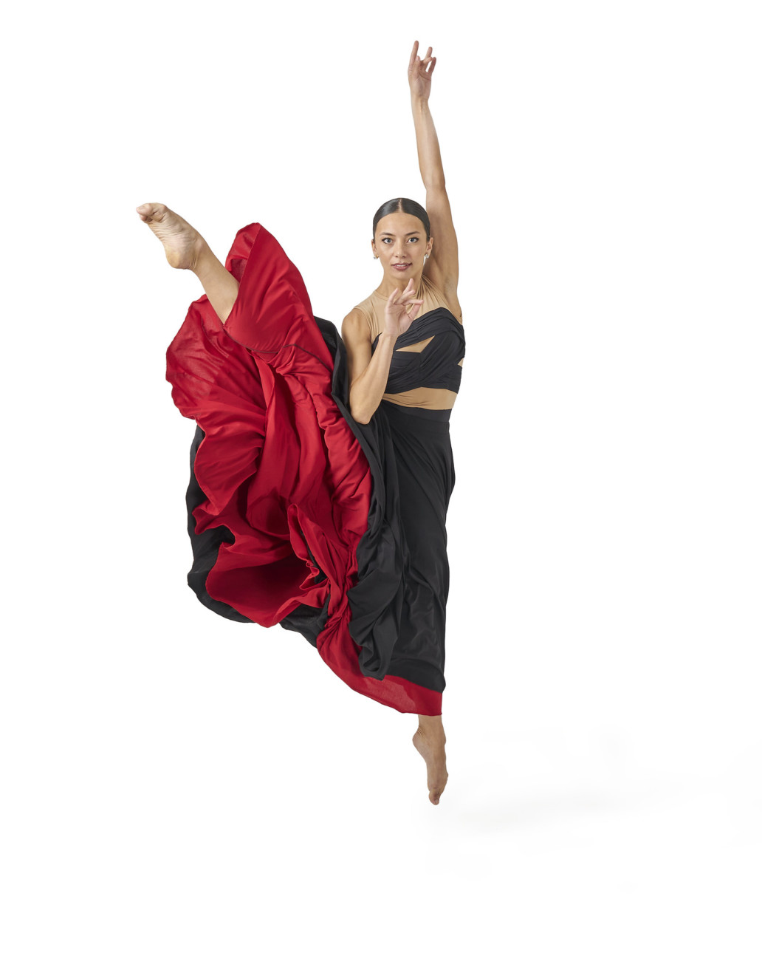](https://www.mutualdance.org/v2020/wp-content/uploads/2021/10/51747413634_4836fa9a74_k.jpg)](https://www.mutualdance.org/v2020/wp-content/uploads/2021/10/51747413634_4836fa9a74_k.jpg)

[[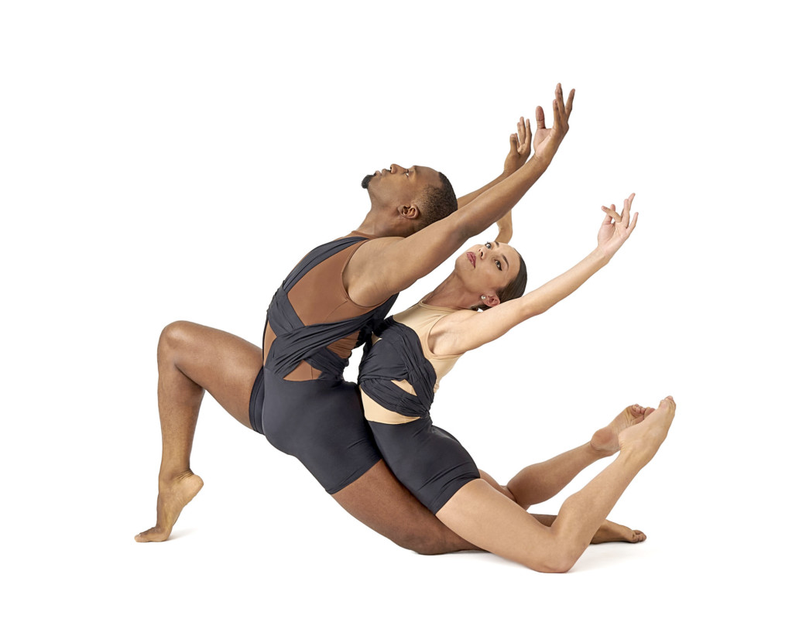](https://www.mutualdance.org/v2020/wp-content/uploads/2021/10/51747003313_7e0c401e73_k.jpg)](https://www.mutualdance.org/v2020/wp-content/uploads/2021/10/51747003313_7e0c401e73_k.jpg)

[[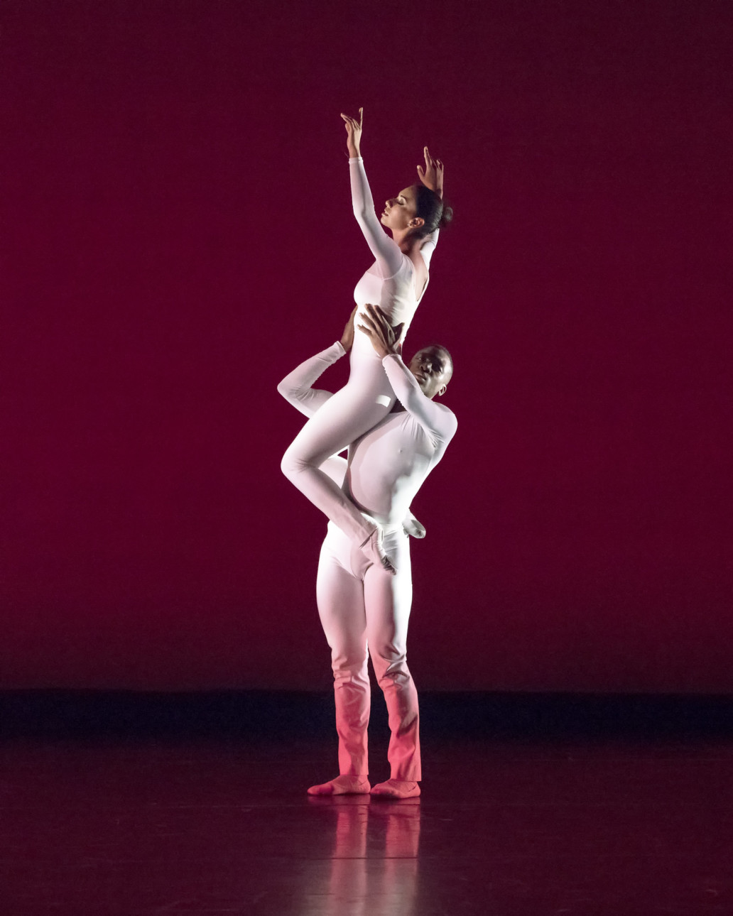](https://www.mutualdance.org/v2020/wp-content/uploads/2021/10/51745940042_6bfcc313d4_k.jpg)](https://www.mutualdance.org/v2020/wp-content/uploads/2021/10/51745940042_6bfcc313d4_k.jpg)

[[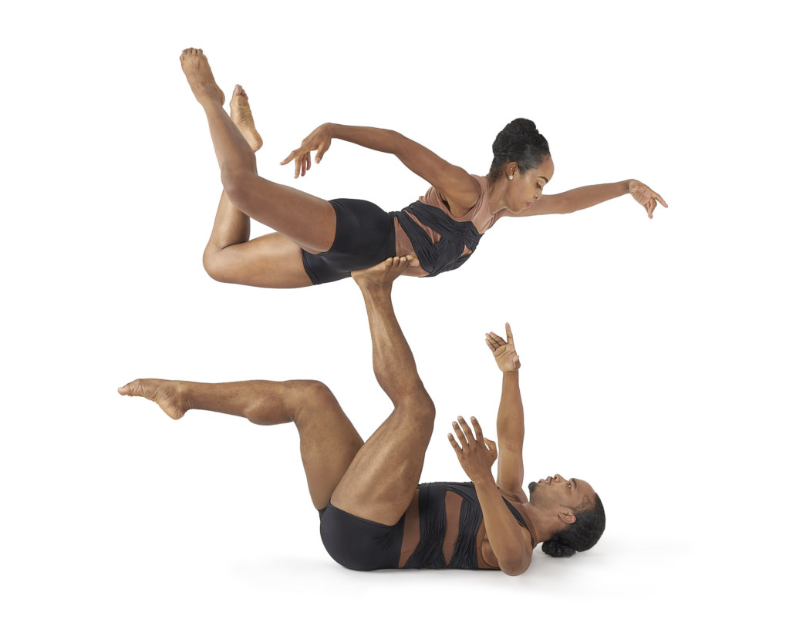](https://www.mutualdance.org/v2020/wp-content/uploads/2021/10/51745940082_d849ebfe2c_k.jpg)](https://www.mutualdance.org/v2020/wp-content/uploads/2021/10/51745940082_d849ebfe2c_k.jpg)

Press contacts

For more information, please email [**jeanne@mutualarts.org**](mailto:jeanne@mutualarts.org) or call 513.494.6526.

Social Media Handles:

Performances: [**Facebook**](http://facebook.com/mutualdance) and [**Instagram**](http://instagram.com/mutualdance) @mutualdance  
The Centers: [**Facebook**](http://facebook.com/mutualartscenters) and [**Instagram**](http://instagram.com/mutualartscenters) @mutualartscenters